TECHNICAL REPORT

INTRODUCTION
SATARK is our urban flood nowcasting and decision-support system for SIH26085. We designed it around a simple idea: a rainfall forecast becomes useful to an operator only when it can be translated into changing flood conditions, infrastructure disruption, population movement and possible response actions.
Our implementation therefore treats the city as a dynamic digital twin instead of a static map. Rainfall and urban-state data establish the initial condition, a backend simulation advances that condition in discrete time, domain algorithms calculate downstream consequences, and the resulting WorldState is exposed through a Django REST API to our React/Three.js command center.
SYSTEM OVERVIEW
We split SATARK into four technical layers. The data and digital-twin layer represents the city, the simulation layer advances the disaster state, the algorithms layer calculates consequences and decisions, and the presentation layer visualizes that state and accepts operator input.

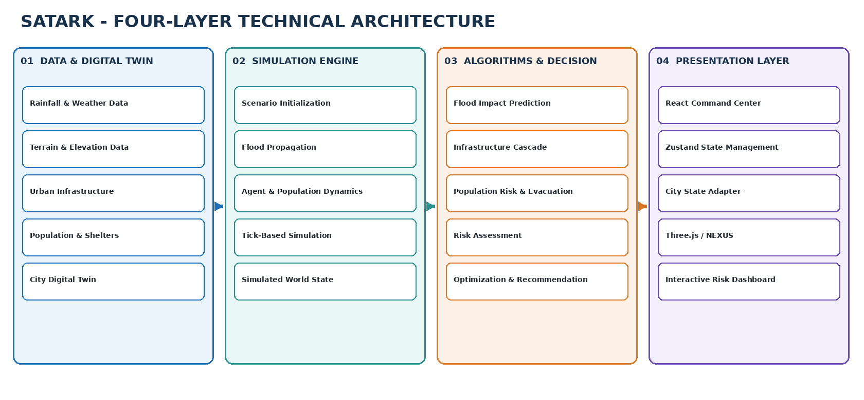
Figure 1. Four-layer SATARK architecture used by our current technical design.

DISCUSSION AND SYSTEM OPERATION
The main technical path in SATARK is the per-tick execution sequence. We keep the order explicit so that each stage receives the outputs of the stages before it. A simulation tick therefore represents one internally consistent city state.
Scenario Initialization
At initialization, we define the calamity type, duration, tick rate, and the initial population and shelter mappings. The current spatial model contains 21 authoritative zones with zone centres and neighbour relationships.
Flood State
The flood stage updates the environmental state. In the current prototype, flood propagation is represented at zone level and the WorldState exposes rainfall intensity and flood-water levels by zone. Our SIH-facing architecture extends this upstream layer toward high-resolution rainfall-nowcast, terrain, surface-flow and coupled drainage modelling.
Flood Impact and Infrastructure
FloodImpactEngine converts the environmental flood state into an impact state. We then propagate consequences through the infrastructure dependency graph, allowing an affected component to change the state of connected services.
Population and Evacuation
HumanAgent entities use explicit NORMAL, PANIC and SAFE states. Normal agents follow configured routes, panic agents move toward eligible safe centres, and safe agents stop. A separate EvacuationEngine performs Dijkstra-based routing over zone neighbours while considering flood levels, blocked routes, panic and shelter availability.

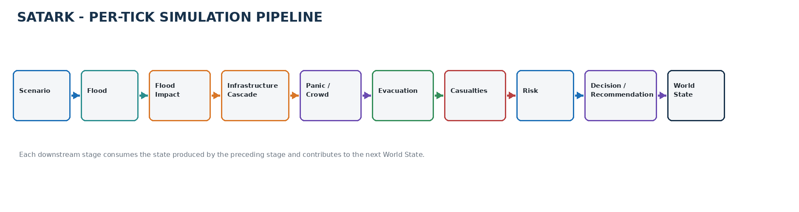
Figure 2. SATARK per-tick backend sequence.

DISCUSSION AND SYSTEM OPERATION – CONTINUED

Casualties and Risk
After the population response is updated, the casualty stage records human consequences and the risk stage produces the composite risk state. The documented risk output contains flooding, infrastructure, casualties and congestion components. We have not stated a fixed weighting formula because the supplied implementation audit does not specify the final coefficients.
Counterfactual Decision Layer
The main decision step is what separates our system from a simple monitoring dashboard. Instead of applying an intervention immediately, SATARK can evaluate it as a candidate scenario, compare the outcome with a baseline, and return the resulting improvement metrics.

DECISION | The optimizer exposes baseline metrics, intervention results, risk reduction, casualty reduction, infrastructure improvement and congestion improvement.

WorldState
WorldState is the authoritative in-memory representation of the simulation. It carries simulation time, entities, environmental state, metrics, events, risk, recommendations, optimization results and intervention state.
Representative Population
The source population dataset represents approximately 250,000 residents. We use 250 representative HumanAgent entities by default so the simulation and 3D visualization do not need to transfer hundreds of thousands of individual objects.

DATA MODEL

Spatial: | 21 authoritative zones from glb_zone_mapping.json; center positions and neighbour connectivity.
Population: | Zone-level population estimates and representative-agent weighting.
Shelters: | Facility position, capacity and operational/safe-center state.
Infrastructure: | Facility type, zone association and dependency state.
WorldState: | Simulation tick/time, entities, environment, metrics, risk and decision outputs.

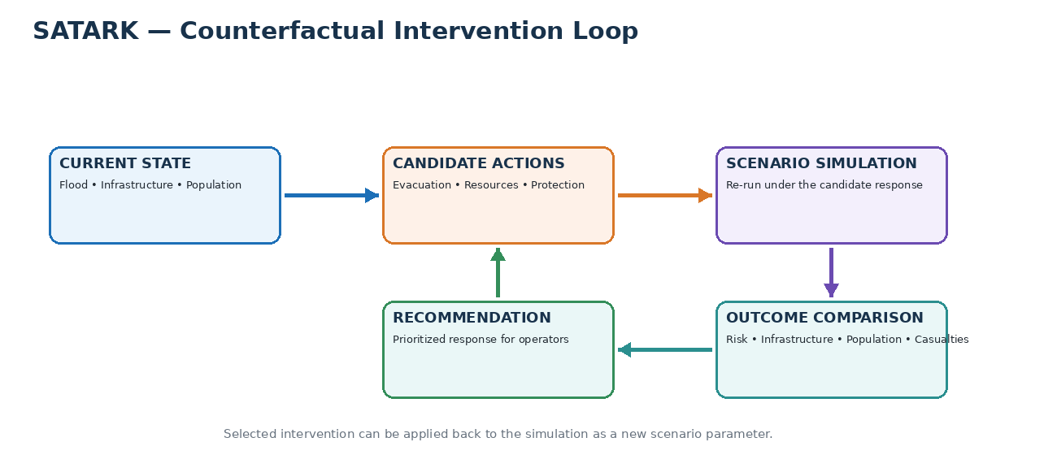
Figure 3. Counterfactual intervention evaluation: baseline, scenario simulation, outcome comparison and recommendation.

TECHNICAL PROCEDURES

Flood Modelling Path
Rainfall forcing
|
Terrain / surface representation
|
2D surface-water propagation
<->
Stormwater drainage network
|
Flood depth / inundation state
|
Street / intersection risk

The prototype stores evolving flood-water state by zone. The PS26085-complete architecture is intended to replace or augment this upstream representation with a higher-resolution rainfall, terrain, surface-flow and drainage model. The downstream SATARK interfaces remain the same.

API and Control Path
Django REST Framework is the boundary between the simulation backend and the command center. The current documented interface includes initialization, state retrieval, single-step advancement, run, pause, resume, reset, risk, recommendation, optimization and intervention operations.
POST /api/simulation/initialize | Create the active simulation and return initial state.
GET /api/simulation/state | Return stored WorldState without advancing time.
POST /api/simulation/step | Advance exactly one simulation tick.
POST /api/simulation/run | Execute repeated step() calls until completion.
GET /api/risk | Return current risk state.
GET /api/recommendation | Return recommendation output.
POST /api/optimization | Evaluate candidate interventions.
POST /api/intervention | Apply an intervention.

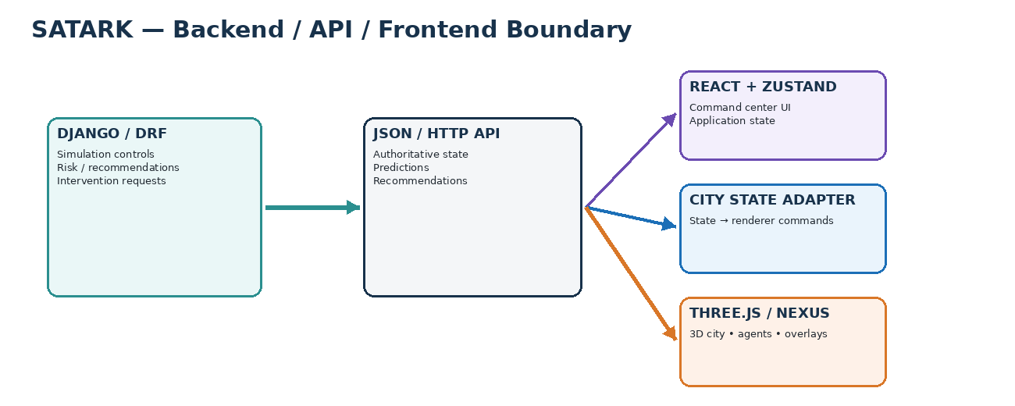
Figure 4. SATARK backend/API/frontend boundary. Backend state remains authoritative.

TEST PROCEDURES
Data and Schema Validation
- Validate the 21-zone mapping, neighbour connectivity, population data, shelter data and infrastructure records before initialization.
- Keep the spatial coordinate contract consistent between the GLB city model and backend entity positions.
- Record dataset versions used for every controlled scenario.
Simulation Validation
- Run a fixed scenario repeatedly where deterministic behaviour is expected.
- Verify that one /step call advances exactly one simulation tick and returns the updated WorldState.
- Verify that /state is read-only and does not advance simulation time.
Routing and Population Validation
- Check that evacuation paths respect flood state, blocked routes and shelter availability.
- Verify HumanAgent transitions through NORMAL, PANIC and SAFE as configured.
- Check representative-agent movement against the intended spatial coordinate system.
Decision Validation
- Run a baseline and candidate intervention with identical initial conditions.
- Compare risk, casualty, infrastructure and congestion outputs.
- Store scenario inputs and software version with each quantitative comparison.

TECHNICAL EVIDENCE AND CURRENT STATUS

The supplied project audits establish the simulation, risk, infrastructure, agent and frontend architecture at the current project resolution. The SIH-facing architecture adds the higher-resolution rainfall, terrain and drainage coupling required by PS26085. We keep those two levels distinct so the technical description stays consistent with what the project actually demonstrates.
Current prototype: | 21-zone digital twin, tick-based simulation, representative agents, evacuation, risk, intervention comparison and React/Three.js command center.
PS26085 extension: | High-resolution rainfall-nowcast fusion, terrain/surface routing, explicit drainage graph, hydraulic capacity/surcharge and street/intersection flood output.
Transport: | REST/JSON in the current audited API; no WebSocket/SSE implementation documented.
Deployment: | Production use requires per-simulation/session isolation, asynchronous execution and persistence.

RESULTS AND TECHNICAL OUTPUTS

SATARK produces one evolving state that can be inspected from several views. The flood layer contributes water-depth and inundation state; the infrastructure layer contributes dependency consequences; the population layer contributes movement, congestion and casualty state; and the decision layer produces risk, recommendations and intervention comparisons.

Primary Backend Outputs
Simulation: | currentTick, simulationTime, activeCalamity and subsystem state.
Entities: | Representative agents with id, position, state, zoneId and type.
Environment: | Rainfall and flood-water state.
Risk: | Composite risk score, severity label and flooding/infrastructure/casualties/congestion breakdown.
Optimization: | Baseline/candidate outcomes and improvement metrics.
Intervention: | Selected and applied intervention state.

DISCUSSION AND CONCLUSIONS

SATARK's technical design follows one continuous chain: environmental inputs establish the city state, the simulation advances that state, consequence modules determine what changes, and the decision layer evaluates what could be done about it. The 3D command center is the final presentation of that chain rather than an independent model.
The main architectural decision is the separation of responsibilities. WorldState gives every subsystem a common representation; SimulationEngine controls time; the algorithm layer handles flood impact, dependencies, population response, evacuation, risk and intervention logic; Django REST exposes state and control; and React, Zustand, CityStateAdapter and Three.js/NEXUS render that state for the operator.
OUR SYSTEM | SATARK simulates how a flood changes the city, measures what that change does to people and infrastructure, and lets us compare response scenarios before action.

REFERENCES
[1] SATARK Phase 7 - Full System Audit, 23 August 2026. Internal project document.
[2] SATARK Phase 0.5 - Frontend Architecture Lock, August 2026. Internal project document.
[3] SATARK - Agent Backend Information Report, 23 August 2026. Internal project document.
[4] SATARK - Frontend Integration Gap Assessment, August 2026. Internal project document.
[5] Ctrl Character - SIH 2026 presentation deck. Internal project document.
[6] Smart India Hackathon 2026, SIH26085 - Urban Flood Nowcasting System (Drainage and Rainfall Coupling), Ministry of Earth Sciences / NCMRWF.
[7] India Meteorological Department - Greater Mumbai Urban Meteorology / Districtwise Nowcast.
[8] Water (2026), SWMM-Based Hydrological Modelling of Blue-Green Infrastructure for Climate-Resilient Stormwater Management and Urban Flood Reduction in Greater Mumbai, 18(13), 1542. DOI: 10.3390/w18131542.

